Contact Management System

Project Structure
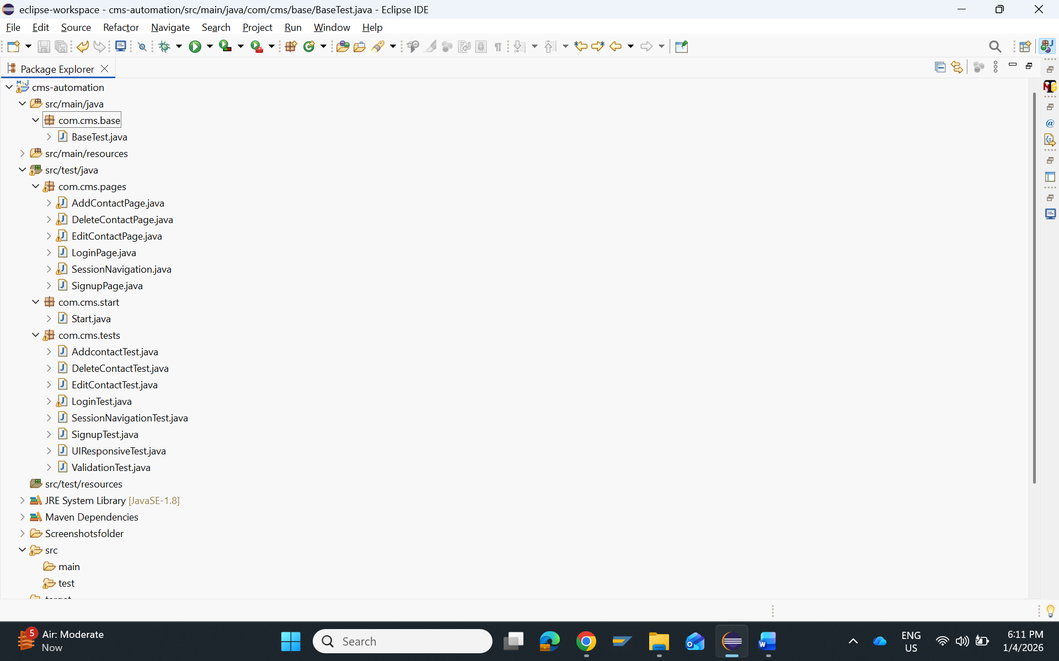

Testng XML code:
<?xml version="1.0" encoding="UTF-8"?>
<!DOCTYPE suite SYSTEM "https://testng.org/testng-1.0.dtd">
<suite name="Suite">
<test name ="CMS">
<classes>
<class name="com.cms.tests.SignupTest"/>
<class name="com.cms.tests.LoginTest"/>
<class name="com.cms.tests.AddcontactTest"/>
<class name="com.cms.tests.EditContactTest"/>
<class name="com.cms.tests.DeleteContactTest"/>
<class name="com.cms.tests.SessionNavigationTest"/>
<class name="com.cms.tests.UIResponsiveTest"/>
<class name="com.cms.tests.ValidationTest"/>
</classes>

</test> <!-- Test -->
</suite> <!-- Suite -->

src/main/java/com.cms.base
BaseTest.java
package com.cms.base;

import java.io.File;
import java.io.IOException;
import java.time.Duration;

import org.apache.commons.io.FileUtils;
import org.openqa.selenium.By;
import org.openqa.selenium.OutputType;
import org.openqa.selenium.TakesScreenshot;
import org.openqa.selenium.WebDriver;
import org.openqa.selenium.WebElement;
import org.openqa.selenium.chrome.ChromeDriver;
import org.openqa.selenium.firefox.FirefoxDriver;
import org.openqa.selenium.support.ui.ExpectedConditions;
import org.openqa.selenium.support.ui.WebDriverWait;

import com.aventstack.extentreports.ExtentReports;
import com.aventstack.extentreports.ExtentTest;
import com.aventstack.extentreports.reporter.ExtentSparkReporter;

public class BaseTest {

public static WebDriver driver=null;
public static ExtentSparkReporter reporter;
public static ExtentReports report = null;
public static ExtentTest test = null;

public static void getReport() {
reporter = new ExtentSparkReporter(System.getProperty("user.dir") + "/CmdTestReport.html");

reporter.config().setReportName("CMS Automation Report");
reporter.config().setDocumentTitle("Test Execution Report");

report = new ExtentReports();
report.attachReporter(reporter);

}

public static void StartBrowser(String browser) {

switch(browser) {
case "chrome":
driver = new ChromeDriver();
break;
case "firefox":
driver = new FirefoxDriver();
break;
default:
driver = new ChromeDriver();
}

driver.manage().window().maximize();
driver.manage().timeouts().implicitlyWait(Duration.ofSeconds(50));
driver.get("https://thinking-tester-contact-list.herokuapp.com/");
}

protected void CloseBrowser() {

driver.close();
}

public static void ElementClick (WebElement element) {
element.click();
}

public static void ElementSendKeys (WebElement element,String Value) {
element.clear();
element.sendKeys(Value);
}

public static String ElementGetText (WebElement element) {
String value ="";
value = element.getText();
return value;
}

public void pagewait() {

WebDriverWait wait = new WebDriverWait(driver, Duration.ofSeconds(10));
WebElement expectedelement= driver.findElement(By.xpath("//h1[text()='Contact List']"));
wait.until(ExpectedConditions.visibilityOf(expectedelement));
if(expectedelement.isDisplayed()) {
System.out.println("Redirected to the expected page");
}
else {
System.out.println("Redirected to the incorrect page");
}

}

public static String captureScreenshot(String testName) {
TakesScreenshot ts =(TakesScreenshot)driver;
File src=ts.getScreenshotAs(OutputType.FILE);
String destPath = System.getProperty("user.dir")+"/Screenshotsfolder/"+testName+".png";
try {
FileUtils.copyFile(src, new File(destPath));
} catch (IOException e) {
// TODO Auto-generated catch block
e.printStackTrace();
}
return destPath;
}

}

Src/test/java/com.cms.start
Start,java
package com.cms.start;

import org.testng.annotations.AfterMethod;
import org.testng.annotations.AfterSuite;
import org.testng.annotations.BeforeMethod;
import org.testng.annotations.BeforeSuite;
import com.cms.base.BaseTest;

public class Start extends BaseTest {

@BeforeSuite
public void beforesuite() {
getReport();
}

@AfterSuite
public void aftersuite() {
report.flush();
CloseBrowser();
}

@BeforeMethod()
public void beforemethod() {
StartBrowser("chrome");
driver.get("https://thinking-tester-contact-list.herokuapp.com/");
}

@AfterMethod()
public void aftermethod() {

}
}

